


Leaf Health Check
Examining plant leaves to determine if the plant is healthy or sick

Team ID:
Team Leader: MALAR SANDHIYA B (4F9F629CCE0F90BA8384D8BEC65488F2)
Team Member: VAISALI S (5826C0922A555C0964F42ED460203A2E)
Team Member: DHANA RANJANI K (7FAD81A4239A36F9306497D5D7E83366)
Team Member: DEVA DHARASHINI M (2D5170C61A4CE86A6A54022E76DE1BA5)

Project Description
Monitoring the condition of plants is an important task in agriculture, horticulture, and even in home gardening. Conventional methods used to detect plant diseases mainly depend on manual observation, professional expertise, and a large amount of time. In many situations, early warning signs such as color changes, spots, or texture variations on leaves are not easily noticed. As a result, the disease may spread and cause serious damage to the plant, ultimately affecting crop yield and productivity.
The Leaf Health Check system is designed to solve this problem by offering an AI-based platform for analyzing plant leaves and identifying possible health issues quickly and accurately. This intelligent application is developed using the Streamlit framework, which provides an easy-to-use web interface. Users can simply upload an image of a plant leaf, and the system will instantly analyze it to determine the plant’s health status.
The application utilizes modern image processing methods along with deep learning algorithms to study visible symptoms on the leaf surface. It examines factors such as yellowing, brown patches, dark spots, or other unusual patterns. A discoloration analysis mechanism calculates the affected area on the leaf and helps detect signs that may indicate disease, infection, or nutrient deficiency.
In addition, the system includes a plant identification feature that matches the uploaded leaf image with information stored in a plant database. After identifying the plant species, the platform performs disease detection and determines the seriousness



of the problem. Based on the percentage of damage and the detected symptoms, the leaf condition is categorized into different levels such as Healthy, Mild, Moderate, Severe, or Dying.
To make the tool practical and helpful, the application provides a clear diagnosis along with three customized suggestions for improving plant health. These recommendations may include actions like modifying watering habits, supplying proper fertilizers, increasing sunlight exposure, or applying appropriate plant treatments.
Use Case Scenarios

Scenarios 1:Leaf Image Upload and Health Analysis
Users upload a plant leaf image through the Streamlit interface. The system preprocesses the image by enhancing brightness, resizing it, and removing noise for accurate analysis. The AI model then detects discoloration patterns and predicts whether the leaf is healthy or affected by a disease. The result is displayed along with the severity level and confidence score.

Scenario 2: Plant Species Identification and Disease Detection
The system matches the uploaded leaf image with a plant species database. After identifying the plant type, it analyzes common diseases associated with that species and predicts the most probable condition. This ensures that the diagnosis is plant-specific and more accurate.

Scenario 3: Severity Grading and Rescue Recommendations
The system measures the proportion of the leaf that is affected and studies the color changes present on the surface. Using this information, it determines the seriousness of the plant’s condition. The leaf is then categorized into stages such as Healthy, Mild, Moderate, Severe, or Dying. After evaluating the condition, the system produces three smart recovery suggestions. These tips guide users to take quick steps to protect the plant and restore its health.

Architecture Overview
Leaf Health Check is a smart, AI-based plant monitoring system created to examine images of plant leaves and provide a reliable evaluation of plant health along with useful recovery suggestions. The application is developed using the Streamlit framework and incorporates a deep learning computer vision model to identify color changes in leaves, recognize plant species, and assess the seriousness of possible diseases.
The system accepts leaf images uploaded by the user and analyzes them through image processing techniques. It performs color pattern analysis and plant identification, then produces a detailed diagnostic report. This report includes the severity level of the detected issue and provides personalized recommendations to help restore plant health.




Core Technologies
Streamlit – A framework used to design interactive web applications for AI-driven systems.
Python 3.8+ – Serves as the primary programming language for backend operations and integrating machine learning models.
TensorFlow – Deep learning libraries used for training and implementing plant disease recognition models.
OpenCV – Utilized for image preprocessing and identifying discoloration patterns in plant leaves.
NumPy – Libraries used for efficient data handling, computation, and analysis.
SQLite– Database systems used to store information about plant species and related diseases.
Matplotlib – Tools used for image visualization, manipulation, and processing.

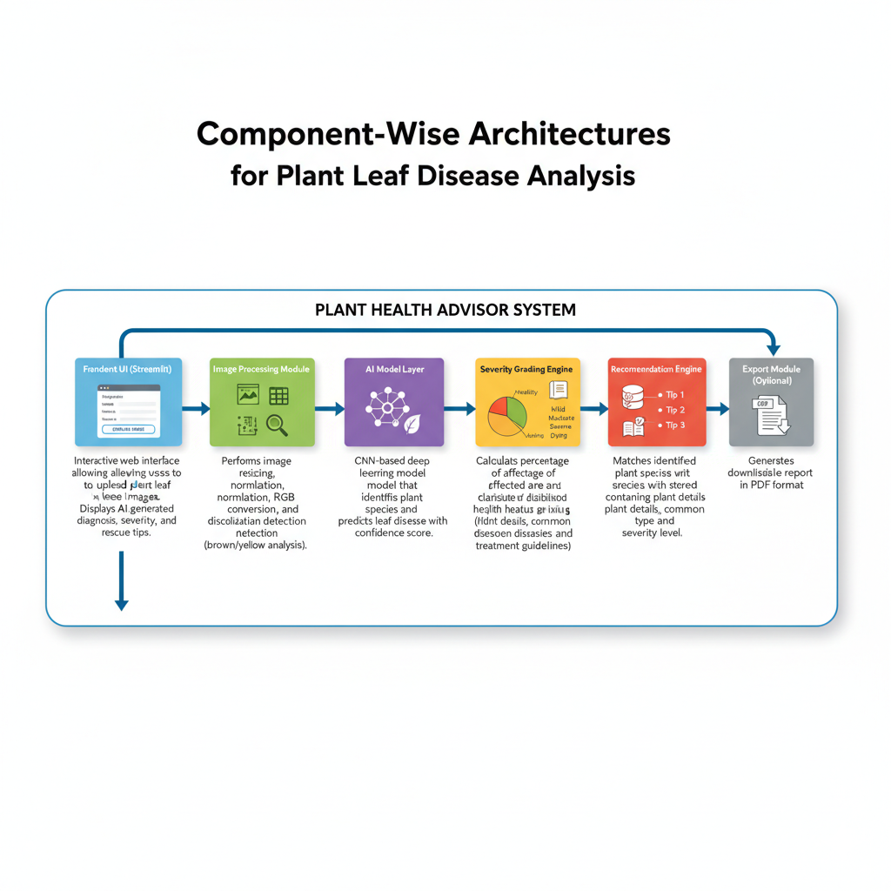
Component | Description
Frontend Interface (Streamlit) | A user-friendly web interface that enables users to upload images of plant leaves. It presents the AI-generated analysis results, including the health status, severity level, and suggested recovery tips.
Image Processing Unit | Handles preprocessing tasks such as adjusting image size, normalizing pixel values, converting images to RGB format, and identifying discoloration patterns like yellowing or browning on the leaf surface.
AI Model Layer | Utilizes a Convolutional Neural Network (CNN)–based deep learning model to recognize plant species and detect potential leaf diseases while providing a prediction confidence score.
Health Severity Analyzer | Determines the proportion of the damaged area on the leaf and categorizes the plant’s condition into levels such as Healthy, Mild, Moderate, Severe, or Dying.
Plant Species Database Module | Compares the detected plant species with entries in a stored database that includes plant information, common diseases, and possible treatment methods.
Suggestion Generation Engine | Produces three tailored recovery recommendations depending on the detected disease and its severity level.
Report Export Module (Optional) | Allows users to download a detailed plant health report in PDF format for future reference.

System Workflow
- User uploads leaf image through Streamlit interface
- Image preprocessing (resize, normalize, noise reduction)
- Discoloration detection (yellow/brown pixel percentage analysis)
- AI model predicts:
  - Plant species
  - Disease class
  - Confidence score
- Severity grading is calculated
- Rescue tips are retrieved from database
- Final diagnosis report is displayed

Severity Grading Logic
- 0–10% Discoloration → Healthy
- 11–30% → Mild
- 31–60% → Moderate
- 61–80% → Severe
- 81–100% → Dying
Severity is calculated based on:
- Percentage of yellow/brown regions
- Disease probability score
- Leaf texture damage

Output Format
Diagnosis Report
Plant Name: <Identified Plant>
Disease: <Predicted Disease>
Confidence Score: <Model Accuracy %>
Severity Level: <Health Grade>
Rescue Tips:
- <Tip 1>
- <Tip 2>
- <Tip 3>

Deployment Architecture (Streamlit Based)
User → Streamlit UI → Image Processing → AI Model → Severity Engine → Recommendation Engine → Output Display
The application can be deployed on:
- Streamlit Cloud
- AWS / Azure
- Local Server

Pre-requisites
- Python 3.8 or above
- Streamlit Framework
- TensorFlow / PyTorch
- OpenCV
- Required Libraries (requirements.txt)

Example installation:
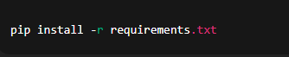
Run the application:
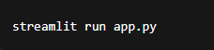



Project Workflow
AI Model Configuration & Initialization
Activity 1.1: Establish the Deep Learning Environment
- Install Python along with the necessary machine learning libraries.
- Set up the working environment for TensorFlow or PyTorch frameworks.
- Obtain and store the plant leaf disease dataset required for model training.
- Check whether the system hardware (GPU or CPU) supports efficient model execution.
Activity 1.2: Environment Setup and Dependency Installation
- Create an isolated virtual environment for the project.
- Install all required libraries and tools listed in the requirements.txt file.
- Configure directory paths for loading trained models and datasets.
- Define settings for image preprocessing operations.
Activity 1.3: Development of Detection Mechanism
- Develop the algorithm responsible for identifying leaf discoloration.
- Specify threshold ranges for detecting yellow and brown color variations.
- Prepare classification labels for different plant species.
- Test the preprocessing pipeline using sample leaf images to ensure accuracy.
2. Development of Core Application Features
Activity 2.1: Build Streamlit Application Framework
- Develop the primary Streamlit application file (app.py).
- Organize the project with a clear modular folder structure.
- Design navigation elements and user interface layout.
- Implement session state management for smoother user interaction.
Activity 2.2: Create Image Upload Functionality
- Allow users to upload leaf images in JPG or PNG format.
- Validate the uploaded file for correct size and format.
- Show a preview of the selected image before analysis begins.
- Display a loading indicator while the system processes the image.
Activity 2.3: Implement the AI Prediction Workflow
- Execute image preprocessing before analysis.
- Run the plant species recognition model.
- Identify the possible disease affecting the leaf.
- Generate a prediction confidence percentage for the results.
3. Backend Processing Development
Activity 3.1: Image Analysis Module
- Adjust image dimensions and normalize pixel values.
- Convert input images into RGB color format.
- Apply filtering techniques to reduce noise.
- Detect regions with discoloration using OpenCV image processing tools.
Activity 3.2: Health Severity Evaluation Engine
- Determine the ratio of damaged pixels on the leaf surface.
- Apply classification rules to categorize plant health into:
  - Healthy
  - Mild
  - Moderate
  - Severe
  - Dying
- Integrate discoloration analysis results with AI model predictions to finalize the health assessment.
Activity 3.3: Species Database Integration
- Create plant species database
- Map detected species with diseases
- Store treatment and care information
- Retrieve matching plant details
Activity 3.4: Recommendation Engine
- Generate rescue tips based on disease
- Adjust tips according to severity level
- Ensure minimum three actionable suggestions

4. UI Development (Streamlit)




4. User Interface Development
Activity 4.1: Design the Interactive User Interface
- Add the application heading and a brief description explaining the tool.
- Create an image upload component for users to submit leaf pictures.
- Include an Analyze button to start the image evaluation process.
- Display a progress spinner to indicate that the system is processing the image.
Activity 4.2: Display Analysis Results
- Present the identified plant species detected by the system.
- Show the predicted disease affecting the leaf.
- Indicate the severity level using a visual status badge.
- Display the model’s confidence percentage for the prediction.
- Clearly list the suggested recovery tips for plant care.
Activity 4.3: Implement Report Export Feature (Optional)
- Allow users to download the plant health diagnosis report.
- Provide an option to export the report in PDF format.
- Manage file naming and ensure smooth download functionality.
5. Testing and System Optimization
Activity 5.1: Functional Verification
- Evaluate the system using images from different plant species.
- Confirm the accuracy of discoloration detection.
- Test whether severity classification works correctly.
- Ensure the user interface operates smoothly and responds properly.
Activity 5.2: AI Model Assessment
- Calculate the model’s prediction accuracy.
- Check the reliability of classification confidence scores.
- Minimize incorrect or false predictions.
- Enhance the quality of image preprocessing techniques.


Activity 5.3: Performance Enhancement
- Improve the speed of image analysis and processing.
- Decrease the time required for loading the AI model.
- Optimize the responsiveness of the Streamlit application.
- Ensure the system can manage invalid or low-resolution images.
Activity 5.4: Deployment Preparation
- Prepare the requirements.txt file containing all dependencies.
- Configure deployment settings for Streamlit Cloud.
- Test the application in a live production environment.
- Verify that the system runs correctly across different platforms.

MILESTONE 1: Gemini AI Initialization
MILESTONE 1: AI Model Initialization
In this foundational stage, the objective is to establish and configure the core AI infrastructure required for the Leaf Health Check system. The platform utilizes a deep learning–based computer vision model to analyze plant leaf images, detect discoloration patterns, identify plant species, and generate health diagnosis with rescue recommendations.
Activity 1.1: Setup Development Environment and AI Model
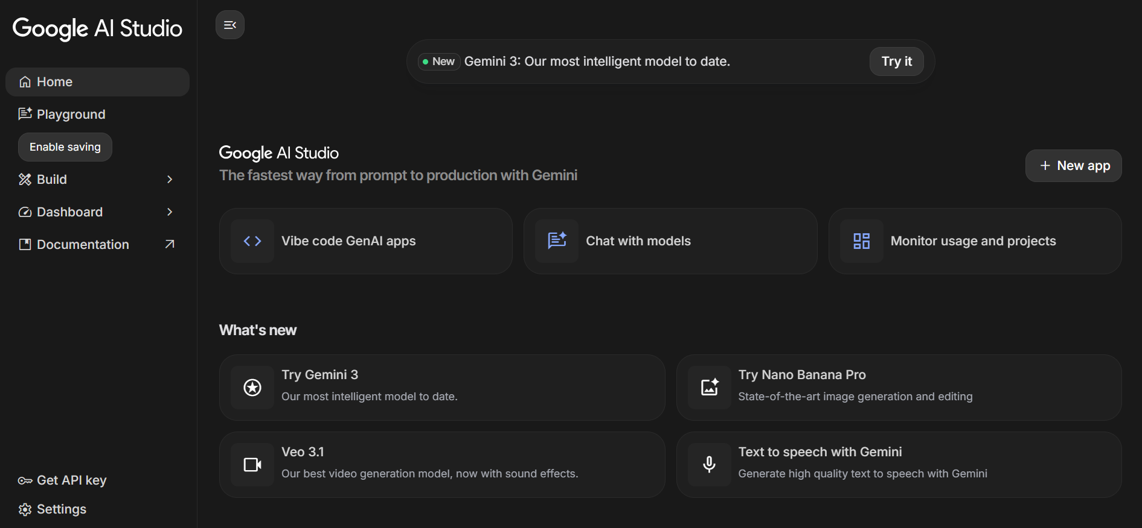

- Download plant leaf disease dataset
Configure trained CNN model (TensorFlow/PyTorch1. Install Required Software
- Install Python (version 3.8 or above)
- Install required IDE (VS Code / PyCharm)
- Setup virtual environment for project isolation
2. Install Required Libraries
3. Prepare AI Model
- )
- Store trained model file inside /model directory
- Verify model loading functionality

Activity 1.2: Configure Environment and Test Setup
1. Create. env File
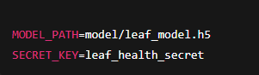
2. Load Environment Variables
Example configuration code:
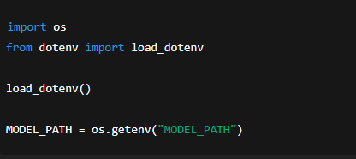
3. Test Model Loading
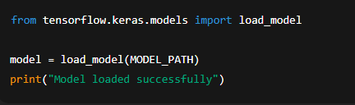
Expected Result:
- Model loads without errors
- Ready for prediction testing

Activity 1.3: Validate Image Processing and Prediction




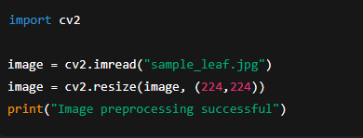

Test Disease Prediction

Test Image Preprocessing

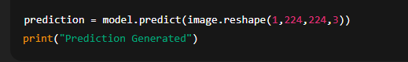
Expected Output:
- Model predicts plant disease class
- Confidence score generated successfully

MILESTONE 2: Core Functionalities Development
This milestone focuses on building the core application using the Streamlit framework integrated with the Google Gemini API. The system accepts plant leaf images, processes visual information, analyzes discoloration patterns, and generates an AI-based diagnosis with severity grading and rescue recommendations.

File Explorer Structure
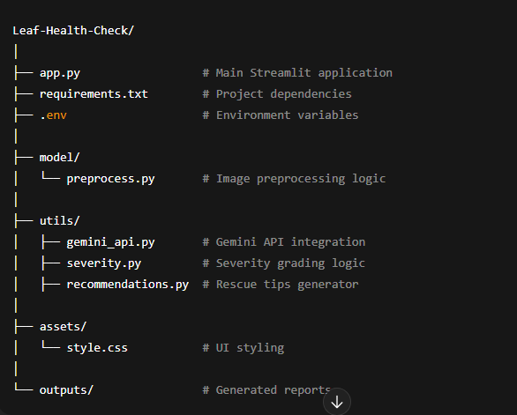



Activity 2.1: Streamlit Initialization and Import Libraries
Import Required Libraries
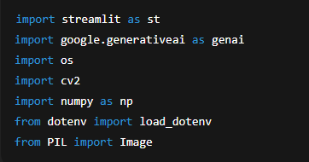
Initialize Environment and Gemini API
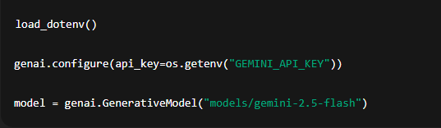
Activity 2.2: Main Functionality – Leaf Analysis Routing
Image Upload Interface
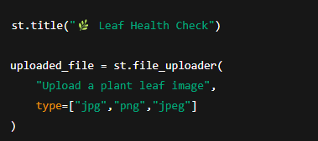

Image Processing
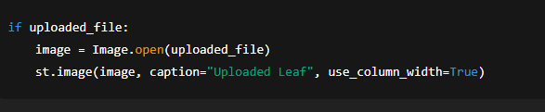
Gemini AI Diagnosis Request
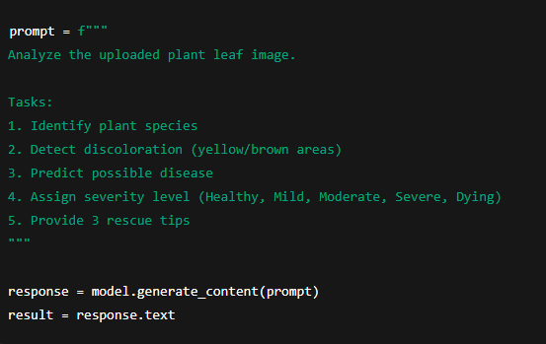



Display Result
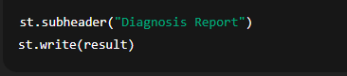
Activity 2.3: Severity Grading Logic
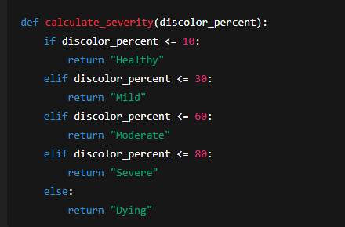
Activity 2.4: Export Functionality
Generate Text Report
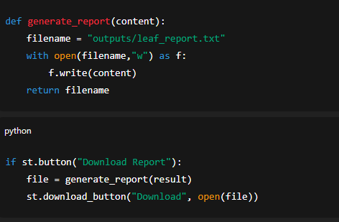

Activity 2.5: Utility Functions
Clean AI Response
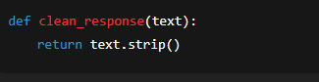




Unique File Generator
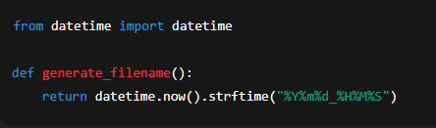

MILESTONE 3: Backend–Streamlit Integration (app.py)
This phase concentrates on developing the full backend functionality within the Streamlit application. It includes integrating the Google Gemini AI Studio API, processing uploaded images, generating diagnostic results, and implementing report export capabilities. The system is designed to maintain proper input validation, deliver organized responses, and ensure seamless communication between the user interface and AI services.
Activity 3.1: Implementation of Core Functions
All backend operations are developed with the following features:
- Verification of uploaded image inputs
- Robust error management mechanisms
- Processing and interpretation of responses from the Gemini API
- Support for logging and debugging to monitor system behavior
- Structured formatting of the final diagnostic results for clear presentation
Image Validation Example
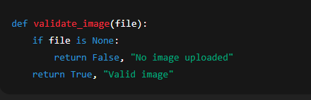
Activity 3.2: Modular Architecture
Main Application Structure
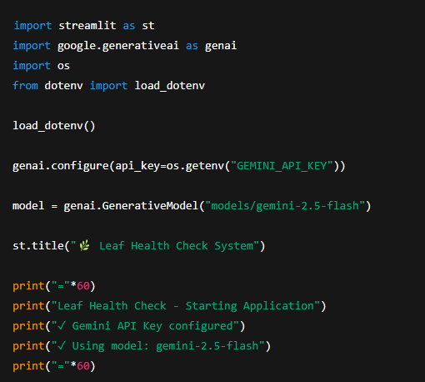


The Streamlit application directly manages:
- User interaction
- AI communication
- Diagnosis generation
- Result visualization

Activity 3.3: Gemini AI Diagnosis Integration

Generate Diagnosis from Image
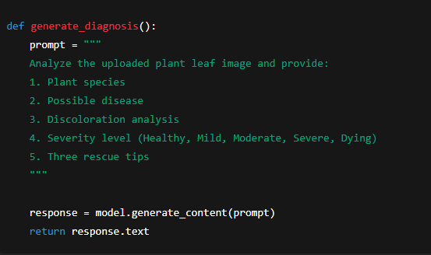
Display AI Response
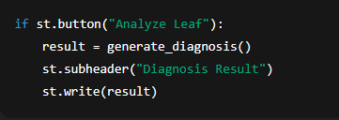
Activity 3.4: Export Implementation
Complete export functionality includes
- Diagnosis report generation
- Downloadable text/PDF report
- File management and naming
Report Generation
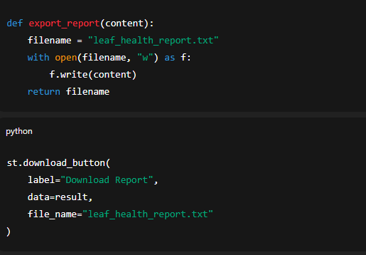



Activity 3.5: Error Handling and Response Formatting
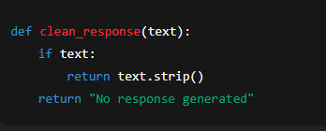

MILESTONE 4: UI Development
This milestone focuses on designing and implementing a user-friendly and responsive interface for the Leaf Health Check application using the Streamlit framework. The UI ensures smooth interaction between the user and the AI system, enabling easy image upload, analysis execution, and result visualization.
Activity 4.1: Home Page Development
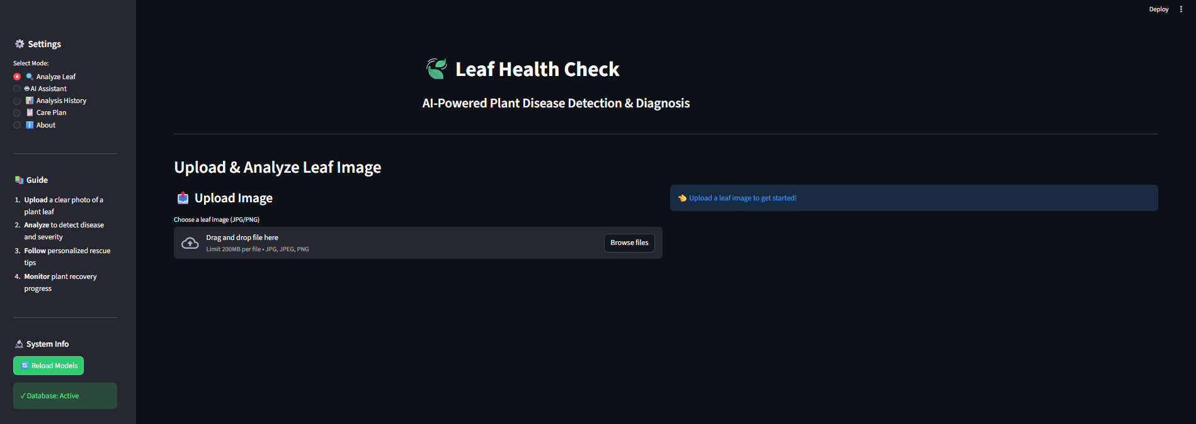
The home page acts as the primary interface for user interaction and provides clear guidance on how to use the application.
Home Page Features:
- Application title and description
- Leaf image upload section
- Supported image format information
- Analyze button for triggering diagnosis
- Clean and responsive layout
UI Design Considerations:
- Simple and minimal design
- Clear instructions for users



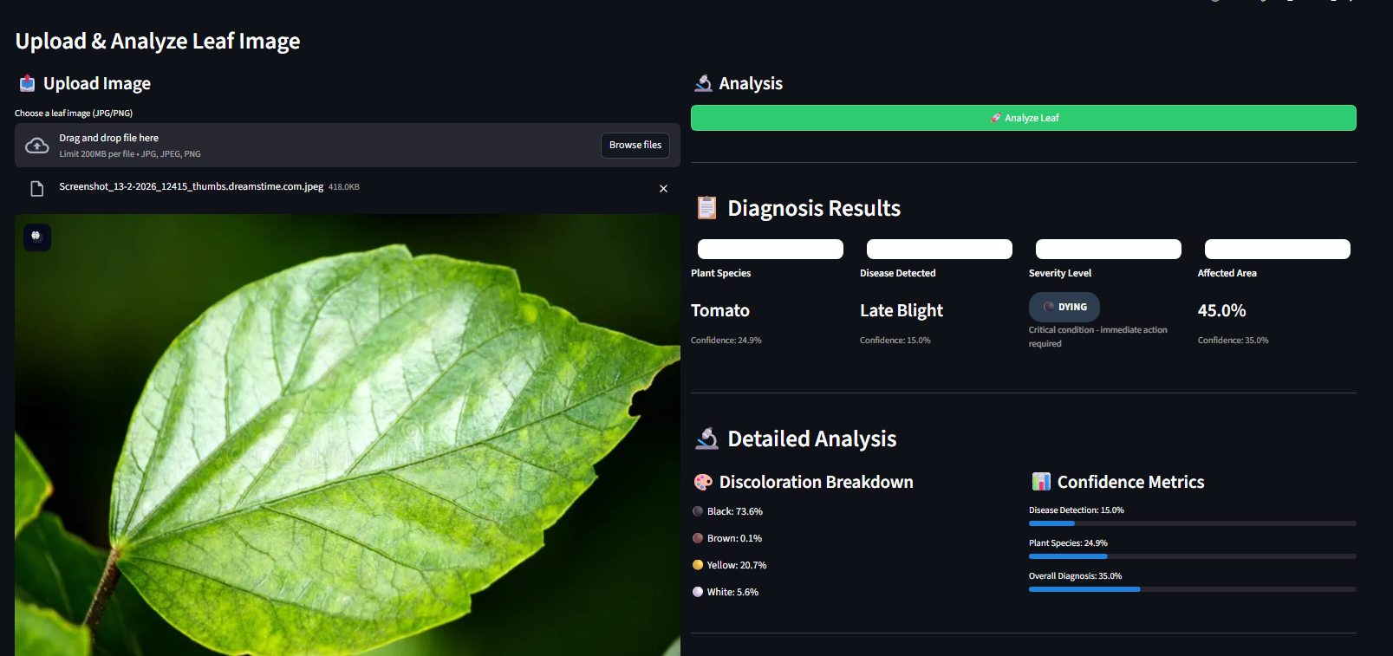

This section handles user input and displays AI-generated results after analysis.
Features Implemented:
- Image preview after upload
- Loading spinner during analysis
- Gemini AI diagnosis display
- Plant species identification
- Disease detection result
- Severity grading badge
Severity Levels Displayed:
- Healthy
- Mild
- Moderate
- Severe
- Dying
Activity 4.3: Rescue Recommendation Display
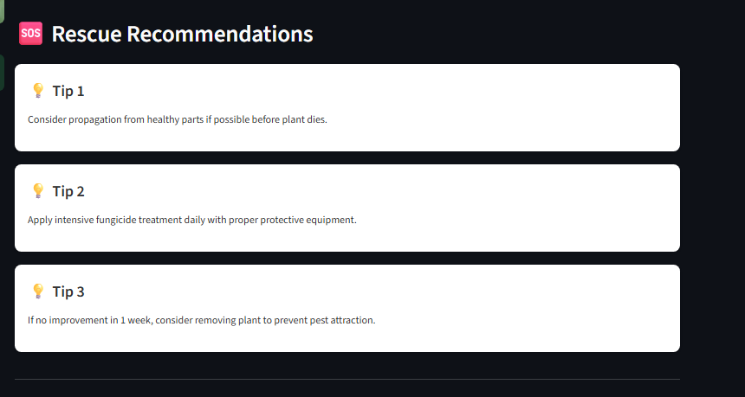
After diagnosis, the system presents actionable rescue recommendations to help users treat the affected plant




Rescue Tips Section Includes:
- Three personalized rescue tips
- Tips based on disease type and severity
- Easy-to-read bullet format
- Practical and actionable suggestions
Activity 4.4: Result Export Option
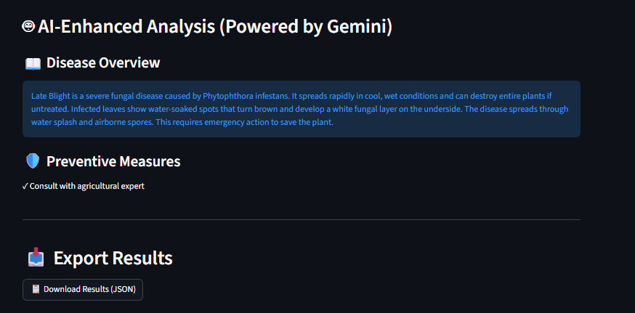

Report Export Options
- Export the diagnosis as a PDF or text file.
- Automatically assign a filename for convenience.
- Include essential details such as the plant type, identified disease, severity rating, and recommended care tips.
Activity 4.5: Error Handling and User Guidance
The application integrates mechanisms to provide clear feedback and improve user interaction.
Situations Addressed:
- Incorrect or unsupported image formats
- Absence of an uploaded image
- Failures in AI response or processing
- Alerts for low-resolution or poor-quality images
Feedback Approach:
- Show informative error messages to guide the user
- Suggest corrective steps for problematic images
- Notify the user of AI or system errors
- Provide tips to enhance image quality for better diagnostic results

MILESTONE 5: Testing & Optimization
This milestone focuses on comprehensive testing, quality evaluation, and performance optimization of the Leaf Health Check application to ensure accuracy, reliability, and smooth user experience. Multiple test scenarios were executed to validate image analysis, AI diagnosis, severity grading, and rescue recommendations.
Activity 5.1: Comprehensive Testing
Test Scenarios
1. Leaf Image Analysis
- Input Type: Plant leaf images
- Formats Tested: JPG, PNG, JPEG
- Conditions: Healthy, diseased, partially damaged leaves
- Expected Output: Accurate diagnosis with severity grading and rescue tips
Test Cases Executed:
- Healthy green leaf image
- Yellowing leaf image
- Brown spot infected leaf
- Severely damaged leaf image
- Low-quality and blurred images

2. Discoloration Detection
- Colors Tested: Yellow, brown, black
- Severity Levels Verified: Healthy, Mild, Moderate, Severe, Dying
- Expected Result: Correct severity classification based on affected area

3. Gemini AI Diagnosis Testing
- API Used: Gemini AI Studio API Key
- Model Tested: Gemini Vision Model
- Expected Output:
  - Plant species identification
  - Disease prediction
  - Confidence-based severity grading
  - Three actionable rescue tips

4. Error Handling Scenarios
- No image uploaded


Activity 5.1: Error Scenarios and Expected Handling
Potential Issues:
- Unsupported or incompatible image formats
- Corrupted or unreadable image files
- Delays or failures in receiving responses from the API
Desired Outcomes:
- Display clear, user-friendly error messages
- Handle failures gracefully without interrupting workflow
- Ensure the application does not crash under error conditions

Activity 5.2: Output Quality Assessment
The system’s performance and output quality were assessed using the following criteria:
- Accuracy of disease diagnosis
- Correctness of severity classification
- Relevance and usefulness of suggested recovery tips
- Consistency of AI predictions
- Clarity and usability of the user interface
- Quality and completeness of downloadable reports
Each result was manually reviewed to confirm logical accuracy and practical value for end users.

Activity 5.3: System Performance Enhancement
Optimization Measures Implemented:
- Accelerated image preprocessing through improved resizing techniques
- Minimized latency in responses from the Gemini API
- Strengthened input validation to prevent errors
- Optimized Streamlit interface rendering for smoother operation
- Added progress indicators to provide better feedback during processing
- Reduced redundant computations by leveraging session state management

Activity 5.4: Final System Verification
Following the optimizations, the system was retested to ensure:
- Stable and reliable application performance
- Accurate predictions from the AI model
- Correct evaluation of severity levels
- Smooth and responsive user interface interaction
- Successful generation and download of plant health reports



Conclusion

The Leaf Health Check project effectively showcases how AI-based image analysis can be utilized for early detection of plant diseases and overall leaf health evaluation. By combining the Streamlit framework with Google Gemini AI Studio, the platform quickly examines plant leaf images to identify potential diseases, detect discoloration, assess severity, and provide practical recovery recommendations.
The system processes images uploaded by users in real time, using Gemini’s advanced visual recognition and reasoning capabilities to deliver precise and actionable diagnostic reports. The Streamlit interface is designed to be intuitive and responsive, allowing users to upload images, view results, and download reports seamlessly without requiring technical expertise. The project emphasizes reliability, user-friendliness, and efficiency through thorough testing, performance optimization, and robust error handling mechanisms.
Overall, Leaf Health Check acts as a smart digital assistant for farmers, gardeners, and plant enthusiasts, supporting timely assessment of plant health and informed decision-making. The project demonstrates the potential of AI-driven solutions in agriculture and provides a foundation for future improvements, such as support for multiple crop types, integration with live camera feeds, and enhanced disease prediction models, advancing sustainable and technology-enabled farming practices.

